The Need for Humans in Game Development.
By Oleh V. Melnychuk
BSC Computer Games Development
L00194760@atu.ie
Wednesday, 17 December 2025
Introduction
The computer game development industry has undergone numerous changes and challenges over its more than 80-year lifespan, resulting in the adoption of new languages, libraries, engines, technologies, hardware, and devices. Every one of these dramatic shifts completely changed new games, allowing for the creation of even more unique and amazing experiences. But it is the first time in the history of this craft when the changes in nature aren’t involving a need for learning a new system or new technology, it is something scarier and tempting at the same time. It is the first time that people can be replaced by algorithms. This is a one step before fully diminishing the connection between players and developers as authors in games. This research seeks to answer the following question: Is a human required in the development cycle of enjoyable games?
I believe that humans are required for the development of an enjoyable game, because the process of game development and design isn’t only making content or code systems, which can be partially replaced even nowadays; games are a source of emotions and experience, which developers want to share with other people (Schell, 2008). Even professional designers mention having struggles to create and design a source of emotions and experience the same way as they expect. It is simply impossible for any kind of technology to predict what an actual player will feel. This problem leads designers to an iterative choice of workflow; instead of trusting and going with the first idea, they make a countless number of prototypes to make one which feels right and give birth to a unique and enjoyable experience (Schell, 2008), which is quite impossible without the involvement of testers and designers to analyse and adapt the game. Iterative design requires developers to deeply understand and modify the smallest bits and holes in the game. If we let an algorithm or a tool do all this, it will lead to a loss of control over the exact details which refine the whole experience. It is a similar concept to asking a language model to write an essay in a language that the user doesn’t know; they will not be able to edit or analyse the grammar and style in this essay.

Discussion
1 Games Shape Humanity
This chapter introduces the reasons why people engage with games and explores the impact games have as a medium for experience, as well as arguing why calculating and automating game design cannot replicate meaningfulness and enjoyment in human-centred design.
1.1 A Game from the Perspective of Game Designers
The word “game” has a lot of different definitions, which do not quite explaining what is commonly named as a game by society; it is also rare to see fun as part of these definitions. Considering this, it will be a better approach to find answers from game designers themselves. Some of them offer their own definition of this word, and commonly, every single one differs from the others (Koster, 2014). Raph Koster himself gives a definition such as “Games are just exceptionally tasty patterns to eat up.” Jesse Schell starts his description of a game with the phrase “A game is something you play.” This is a self-explanatory definition, and it is hard to debate it. To get a deeper understanding, it is important to define the word “play” (Schell, 2008).
What is play? “Play is whatever is done spontaneously and for its own sake.” – George Santayana. It is reasonable to argue about the spontaneity of games, which is not always true, but an important part of a play is that it’s done for its own sake. It is not possible to name something play if a person is forced to do it without their own interest or “sake”. “Whoever must play cannot play.” Even work can easily become play with involvement of personal goal, interest or the sake of doing it; the more it is their own choice more it feels like a play. Jesse Schell suggests his own vision for play as action in which the game is born: “Play is manipulation that indulges curiosity.” This definition interprets inner motivation and curiosity as the drive to seek answers to simple questions, such as “What will happen after this level?”, “Can I beat my last record?”, “Can we defeat this enemy?”, etc. (Schell, 2008).
Considering how wide the definition of the game would be to cover everything that usually counts as a game, it is easier to list essential key aspects which allow an artefact to be considered a game: games are entered wilfully, have goals, involve conflict, operate under rules, can be won and lost, are interactive, present challenges, create internal value, engage players and function as closed, formal systems (Schell, 2008).
Considering definitions, it’s possible to assume that people have some motivation or curiosity to play games; this is the basis for understanding why people even play games. Likely, if a player is asked why he is playing, the most expected answer is “I find playing games fun”, but can any game be fun? It is essential to understand what is fun and what is not. If any game is fun, why don’t people play tic-tac-toe over and over again?
1.2 Definition of Fun
Word fun comes from “fool” or from “pleasure” in different interpretations. But the main meaning is “a source of enjoyment”, not only as physical or mental joy, but also as chemical manipulation. Fun is the release of endorphins. It is a lot of different sensations based on cocktails of chemicals. The pleasurable chills from listening to powerful music are caused by the same chemicals that the person gets from having cocaine, an orgasm or chocolate. “Our brain is technically on drugs all the time” (Koster, 2014)
These insights might be useful for understanding the core of fun, but why do people need fun as a species? Fun is an important survival mechanism which pushes the human species to adapt, learn and master new skills or tasks. As a reward, fun is a moment of pleasure about an accomplished scenario. “Fun is just another word for learning.” (Koster, 2014)
On the other side is boredom – the absence of fun. Boredom is the brain’s reaction to the inability to learn. It is a mechanism that pushes humans into something that can lead to new information or simply fun. Boredom occurs due to a lack of cognitive challenges. But it doesn’t mean that it must be a completely new experience; just new data is enough for the brain to start having fun (Koster, 2014).
1.3 Fun and Boredom in Games
The absence of challenge is exactly why tic-tac-toe is not as fun as other games can be. But the absence of data is not the only reason why a game can become unfun. Humans often experience “sensory overload” when the brain receives overwhelming and complex data. This state is the opposite of “sensory deprivation” (Koster, 2014). For the game to stay fun, it needs to balance between deprivation and overload. Players get bored once they master a skill or realise that they can’t get better. According to (Koster, 2014) the most popular reasons for a game to become boring include a lack of early challenge, excessive depth that overwhelms players or makes them think depth is out of their interest, and a failure by players to recognise underlying patterns, which leads to the game looking like noise. Additionally, boredom may result from poorly adjusted difficulty progression: a difficulty curve that increases too slowly can make the game appear trivial, while one that escalates too rapidly can make the experience feel chaotic or too difficult. Finally, boredom may occur when players fully master patterns and systems no longer provide new challenges – in other words, when the game has been completed.
Not all sources of boredom affect players in the same way. A good game is the one that teaches everything it has to offer before the player stops playing. A major part of the fun in games is based on learning or mastering a certain skillset, while keeping the challenge not overwhelming or underwhelming. It is not as easy as “learning makes games fun.” Designers need to take into account all small variables to make people enjoy, struggle, learn and master without getting bored. (Koster, 2014)
1.4 Other Reasons to Play
It is important to consider fun, but is it the only reason to play? Some games can be named amazing teachers, but why? A big part of learning dominance of games is the example of Miller’s pyramid of learning. This model presents learning as steps towards full acknowledgement, it includes steps such as: “Knows”, “Knows how”, “Shows”, “Does”. Games are located in a unique spot in this model. They focused on the last step – “Does”. Most of the experience and learning in games happens in practical examples, where players rarely have full explanations; instead, they encounter “Does” immediately. This achieves the best results in learning, even sometimes by skipping all previous steps (Schell, 2008).
No less important is how games are changing players. It is a controversial topic to discuss. Some people consider games to have a dangerous effect on human’s brain, causing violence and addiction, at the same time as others completely deny any long-term effects. In contrast, there is a movement of games which tries to teach people and showcase important things that most of them are missing, even changing the whole worldview of players. (Schell, 2008) Not all games lead to the same emotions and experiences; some of them could help emotionally get through hard personal issues, help vent anger and frustration, cheer the player up, build confidence or simply relax (Schell, 2008). Games are a unique and useful tool to help people connect, acting as some sort of social bridge, building mutual interest among speakers or just by making communication easier with each other by solving problems together, which will lead to shared memories after a game ends (Schell, 2008).
1.5 Importance of Experience
Games can affect players' lives, but what actually transforms them is experience, and this is exactly what the whole goal of games is: to share, create or imagine experience. Exactly, experience changes a person’s way of thinking and the way they see the world, from simple communication patterns used on a day-to-day basis, up to deep thoughts and the way they think about simple things. Many aspects of a person’s life are shaped by past experiences. Games play a role in making people have this experience with minimal friction. This leads to the thought that developers should question themselves at one point, “How can my game change players for the better/worse?” (Schell, 2008).

1.6 Why do People Choose to Play?
Taking into account the reasons discussed above, games are part of our lives; they are an experience. People seek fun, emotions and experience in a way that allows them to experience new emotions with less friction. It is easier and much safer to play a game about a submarine expedition than actually to be in one in real life. Experience will be completely different, but it will achieve the goal of fulfilling the player with new experience, mechanics, story and struggles that might be completely new for a player. People have an internal, nearly infinite source of curiosity, and this urge for new data is pushing us to gather new experiences, and games just happen to be the “…exceptionally tasty patterns to eat up”. (Schell, 2008; Koster, 2014)
1.7 Human Need in Design
Considering the numerous variables, can a game be simply trusted to be designed by the machine? I believe the answer is strictly “No”. Games are not a piece of content and code in the engine. Games are something unique, which allow people to share experiences, teach, help with struggles, connect with other people, and open eyes to something they never thought about. Games are shaping humanity, and this shaping requires an amazing level of balance and thoughtfulness to stay healthy and enjoyable. Game Designers spent nearly a century learning and trying to understand how to share their ideas and goals with players through a piece of software, creating a unique experience from cold bits and bytes on our computers. This is just impossible with current technologies to explain these principles to an algorithm which can only find and recreate patterns.

2 Importance of the Iterative Design Process
Prototyping and playtesting are essential tools used by designers to overcome challenges encountered during the design process. These methods allow designers to experiment, identify potential issues, and refine their designs before final implementation. The following subsections explore these tools in more detail.
2.1 Prototyping
The word “Prototyping” means creating a rough example of the final product to have the opportunity to test how it works beforehand. Usage of prototyping allows designers to make great designs through a repetitive process of testing and adjusting the project without a giant loss of development progress if some design decisions don’t work (Fullerton, Swain and Hoffman, 2004). The main advantage is adjusting mechanics in their purest form. If this mechanic already brings joy and interest to players, all later details will enhance the whole experience. The basic mechanical design of the most successful games is extremely straightforward, and this allows designers to carefully control and lead the game model to the way it will function. But making game design is harder than it sounds, and it has a lot of limitations on its own (Fullerton, Swain and Hoffman, 2004). For example, it is important to remember that a player is a person and humans have some limitations. An interesting example is the limit of processing information. Human beings can track and control around 7±2 ideas at the same time (Miller, 1956). It is easy to fall for the mistake of making the design overcomplicated.
2.2 Playtesting
The second part of the toolkit is “Playtesting”, as it can be easily mistaken, the process of playtesting is not an internal design review and is not necessarily bug testing. It is a process of gathering information about what players feel and experience while playing the current state of the game (Fullerton, Swain and Hoffman, 2004). Playtesting helps enhance and refine the player experience in the final product by assisting with identifying and resolving design and technical flaws at relatively early stages of development. This step connects developers with the final consumer as a player by giving feedback on the current game experience (Mirza-Babaei, Moosajee and Drenikow, 2016).
2.3 The Core of Iterative Design
Prototyping and Playtesting are simply the main and most efficient ways of creating good and enjoyable game design. Every successful game was made through a large number of iterations and development cycles. Even if developers challenge themselves to make a game without playtesting, they will most likely fail due to the need to test the currently modified or created mechanics. This is an essential and core aspect which can be seen even in the design of game engines. The approach of the immediate in-editor playtest was designed to merge the development process with playtesting as closely as possible (Unity, no date).
Abstraction and replacement of the complete development cycle with a prompt leading to the full game, which is the only way to completely replace all people in the game development, will lead to the absence of control over detailed game design decisions, as well as playtesting and prototyping. This decision will lead to completely losing control over iterative design, as the most successful tool for developing an enjoyable and balanced design. Creating a game doesn’t mean creating an experience; this is exactly what makes it so hard to do so “Like building a ship in a bottle, we are far removed from what we are actually trying to create” (Schell, 2008).

3 Loss of Control Over Details
To address the last argument, it is important to first clarify what exactly Generative Artificial Intelligence (GenAI) is.
3.1 Generative Artificial Intelligence
Generative Artificial Intelligence, or GenAI, is a model which allows generating certain types of content based on a textual prompt. This ability differs GenAI from common Artificial Intelligence, the goal of which is usually to classify, find or order already existing content. Generation of content from an inside perspective is happening by identifying some hidden underlying structures in the dataset used to learn, and then generating new content or data based on these underlying structures of the original dataset. It is possible to assume that GenAI works by copying some patterns from the original dataset and applying these patterns in the final result. (Bordas et al., 2024)
Considering the key principles which GenAI follows, it can be named as a level of abstraction from the content creation process, considering that abstraction is a process of removing unnecessary details to simplify the model of the entire process, moving from a specific case to a short description, allowing several potential solutions (Ward, 1995).
3.2 Importance of Details
Taking into account the discussed behaviour of the prompt-to-content creation, it leads to a significant loss of control over details, which is crucial when the final goal is to create these details. This contrasts with the deliberate effort of developers, throughout the whole development process, to achieve a believable and enjoyable game by reaching a perfect balance in details, mechanics, difficulties, and content or story reveal.
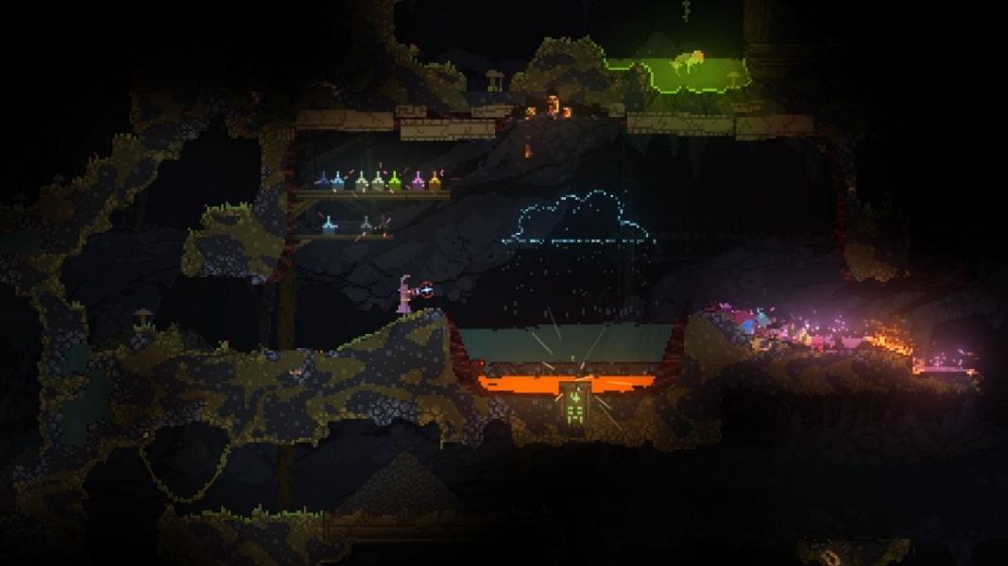
Figure 1: Game “Noita” screenshot
We see how sometimes developers even drop a previous level of abstraction, moving to develop their own custom engine to reach better control and make something unique. An interesting example is the game “Noita”, which achieved a unique experience, gathering more than 80000 reviews with an overall mark of “Overwhelmingly Positive” according to the platform Steam, as a fully interactive and destructible world, which couldn’t be made using usual engines and pathways of development. (Kultima, Ojanen and Nylund, 2024; Noita on Steam, no date)

Conclusion
Games are not as easy as toys. They are not something that can be easily described. Games are complex systems which come through a large amount of work and thought. Their goal is to make us experience something new and unique, which only another person can design. Even professionals in this field make lots and lots of mistakes, and they never blindly trust their first decision, but rather use helpful iterative principles and pathways to achieve the perfect outcome. Abstractions from development will bring only chaos and misunderstanding in the whole cycle, by losing control and understanding of details. I believe that games require humans not only as players, but as developers, designers, artists, writers, and authors. At the end of the day, only a human can understand another human's feelings and experience.
References
Bordas, A. et al. (2024) “What is generative in generative artificial intelligence? A design-based perspective,” Research in Engineering Design, 35(4), pp. 427–443. Available at: https://doi.org/10.1007/s00163-024-00441-x.
Fullerton, T., Swain, C. and Hoffman, S. (2004) Game Design Workshop: Designing, Prototyping, & Playtesting Games. CRC Press.
Koster, R. (2014) A theory of fun for game design. 2nd edition. Sebastopol, CA: O’Reilly.
Kultima, A., Ojanen, R. and Nylund, N. (2024) “Noita: A Long Journey of a Game Idea,” in Transactions of the Digital Games Research Association. Nordic DiGRA, Digital Games Research Association (DIGRA), pp. 155–181. Available at: https://doi.org/10.26503/todigra.v7i1.2186.
Miller, G.A. (1956) “The magical number seven, plus or minus two: Some limits on our capacity for processing information,” Psychological Review, 63(2), pp. 81–97. Available at: https://doi.org/10.1037/h0043158.
Mirza-Babaei, P., Moosajee, N. and Drenikow, B. (2016) “Playtesting for indie studios,” in Proceedings of the 20th International Academic Mindtrek Conference. AcademicMindtrek’16: Academic Mindtrek Conference 2016, Tampere Finland: ACM, pp. 366–374. Available at: https://doi.org/10.1145/2994310.2994364.
Noita on Steam (no date). Available at: https://store.steampowered.com/app/881100/Noita/ (Accessed: December 17, 2025).
Schell, J. (2008) The art of game design : a book of lenses / by Jesse Schell. Elsevier/Morgan Kaufmann.
Unity (no date) Unity - Manual: Unity 6.2 User Manual. Available at: https://docs.unity3d.com/6000.2/Documentation/Manual/UnityManual.html (Accessed: November 6, 2025).
Ward, M. (1995) “A definition of abstraction,” Journal of Software Maintenance: Research and Practice, 7(6), pp. 443–450. Available at: https://doi.org/10.1002/smr.4360070606.

Document Statistics
The document contains 3389 words over 13 pages and was last modified on the 17/12/2025 20:09:00 by Oleh Melnychuk.

